DREAM TEAM

Austin Melendez, Nonika Kathyal, Joshua Langley, Warisara Lee, Danny Phan, Matthew Ryan

California State University, Sacramento

College of Engineering & Computer Science



Project Deliverable #2: Software Requirements & Design Brief

Table of Contents:

1. Page One
   1. Table of Contents
2. Page Two
   1. Software Engineering Team
   2. Project Scope
3. Page Three
   1. UML Models
4. Page Four
   1. System Requirements
5. Page Five
   1. Data Design Models
   2. Architectural Design
6. Page Six
   1. Detailed Design Models
      1. Jane Hopkins Sequence Diagram
      2. FDA and Bavaria Sequence Diagram
7. Page Seven
   1. UI Design and User Stories
   2. User Interface Design Models
8. Page Eight
   1. User Interface Design Models
9. Page Nine
   1. Technology Stack and Tools Used
   2. Assumptions and Project Constraints

**Software Req and Design Brief –V1.1**

1. Software Engineering Team
   1. Team name - Dream Team
   2. Team members - Austin Melendez, Matthew Ryan, Joshua Langley, Danny Phan, Nonika Kathyal, & Warisara Lee
2. Project Scope
   1. The project scope is to “build a proof-of-concept distributed information system with suitable user interfaces that could be used by the FDA, pharmaceutical companies, and participating health care providers to exchange study data as it is produced (i.e., in near real-time) in a secure, trusted (i.e., auditable), and controlled (i.e., minimally permissive) manner.”

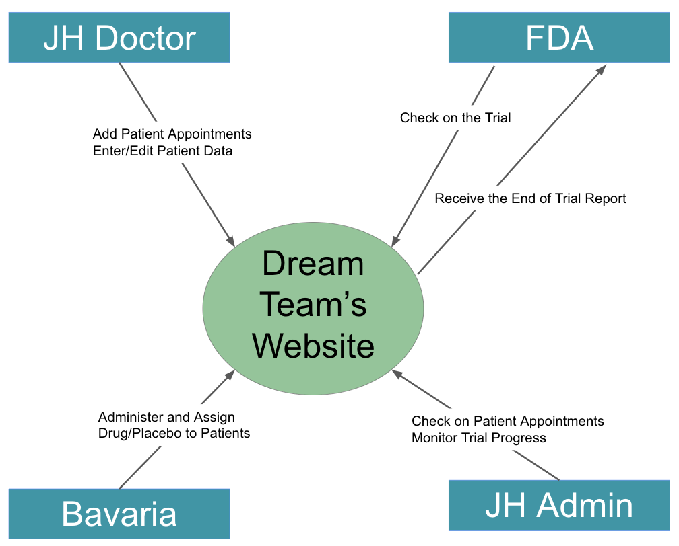

* 1. Our System Context Diagram (SCD) shows how the different end users interact with our website. Each end user interacts with the website differently to monitor and modify the trial. Only the FDA expects to receive a generated End of Trial Report from the website. Every other end-user has a one-way relationship with the website.

1. Object Oriented Requirements Analysis (OOA) – UML Modeling
   1. Use Case Models:
      1. Jane Hopkins Doctor profile logs into the website to view patient data. From that view, the Doctor can edit data, assign trials (placebo or Bavaria drug), and monitor dosages based on appointments.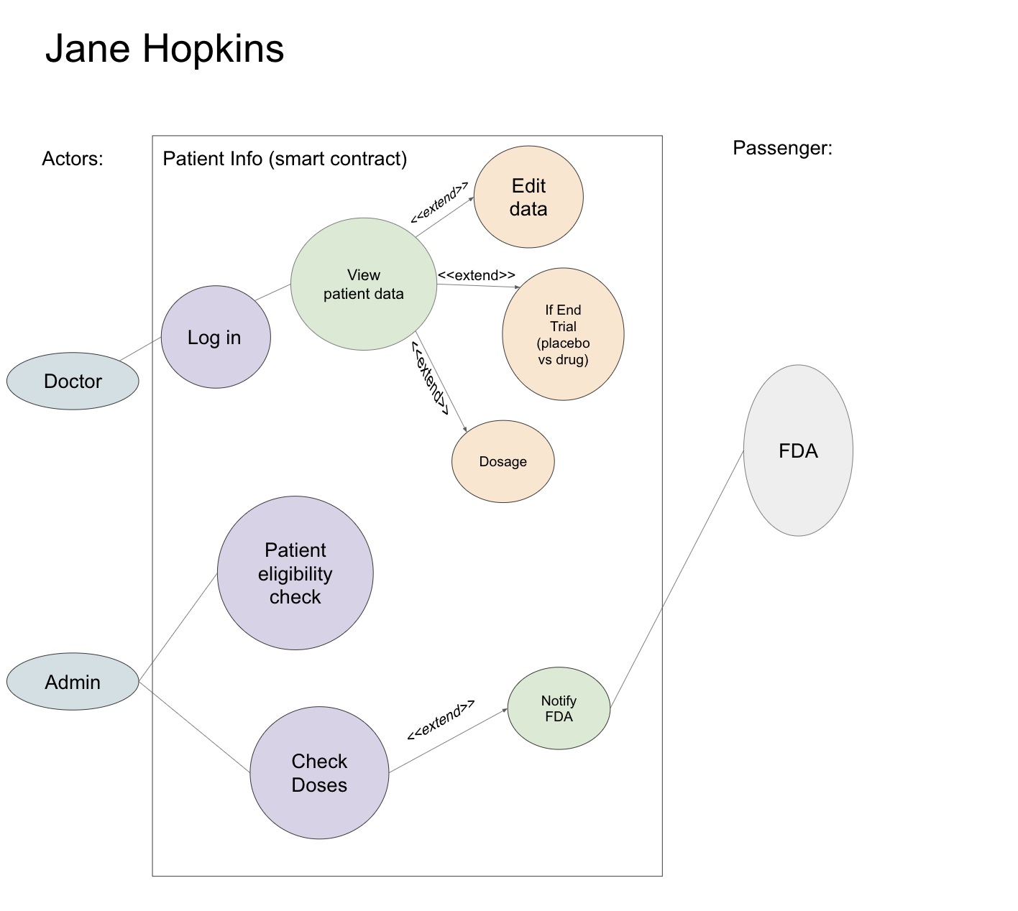
      2. Jane Hopkins Admin profile logs into the website and is responsible for checking patient eligibility and checking dosages. The Admin profile is also responsible for notifying FDA once the trial is completed, providing results but not PII.

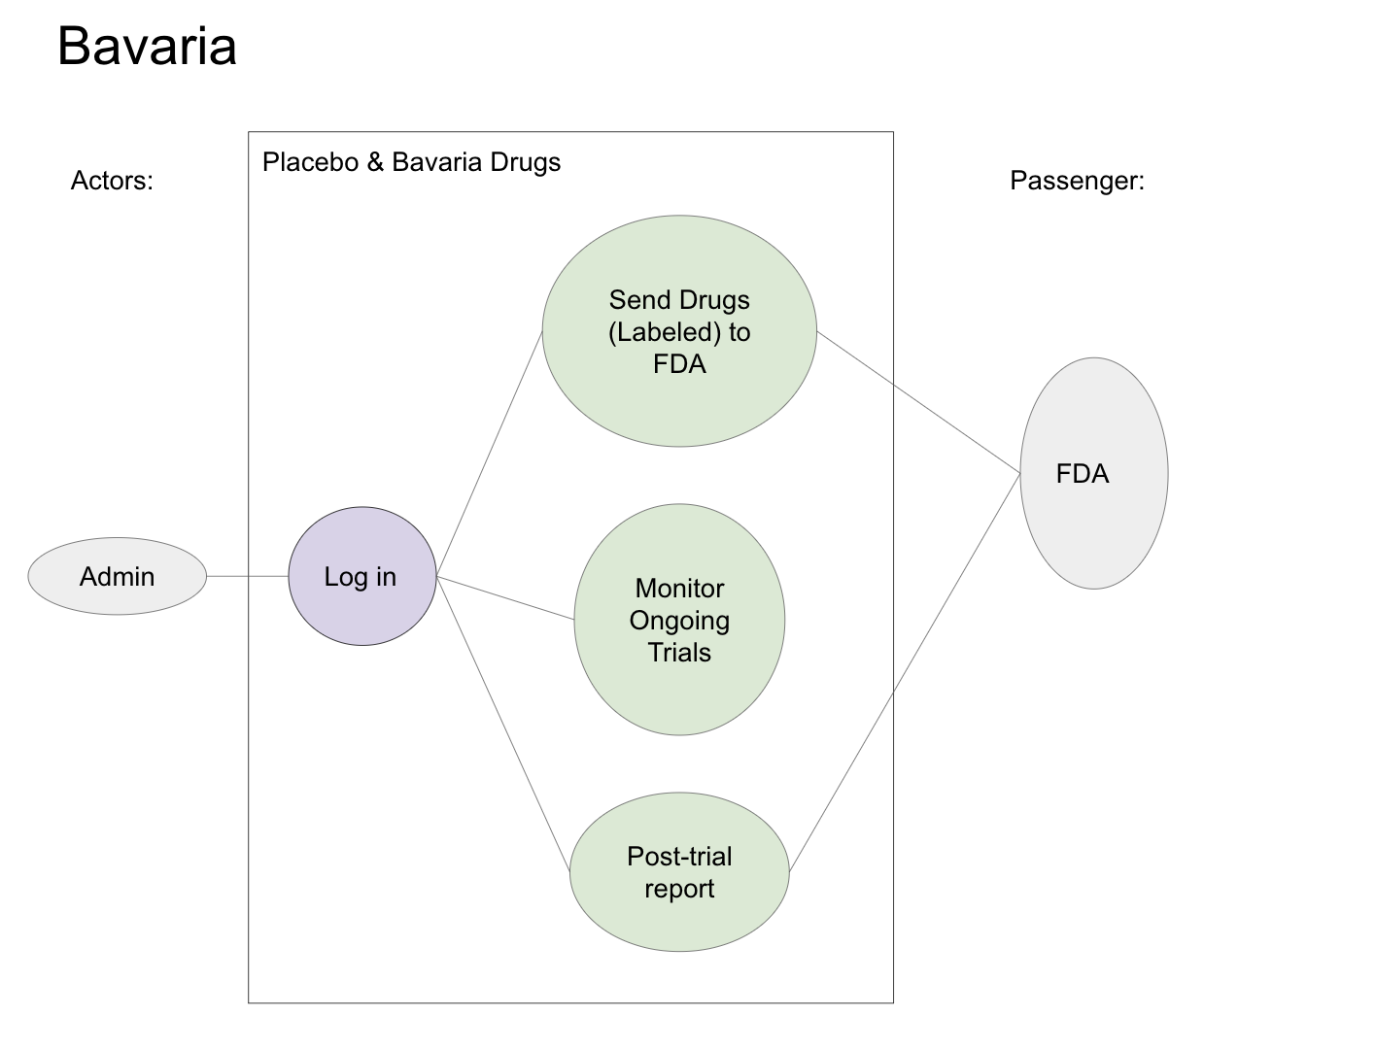

* + 1. Bavaria logs into the website portal and sends drugs (labeled) and post-trial reports to FDA. They are also responsible for monitoring ongoing trials.
    2. FDA Admin logs into the website to assign placebo vs Bavaria drugs to patients and map data for new vs placebo patients UUIDS. FDA shares their information with Jane Hopkins.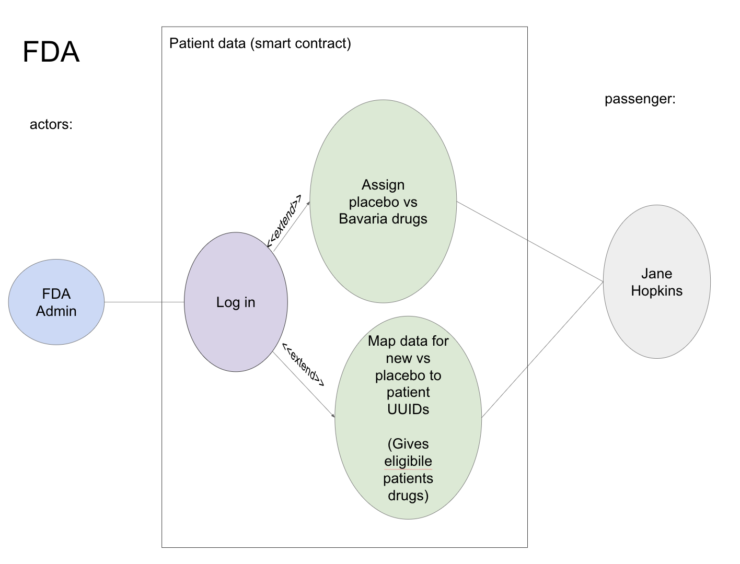
    3. ALTERNATE FLOWS
       1. Access wrong page
       2. Wrong password/email
       3. Create account
       4. Send drugs (no eligible patients) (won't send)

1. System Requirements
   1. 5.1 FRs- Based on the project description and the Use Case model, here are all system functional requirements.

| Functional Requirement No. | Functional Requirement Description |
| --- | --- |
| FR1 | All end-users should be able to log in to their respective websites. (Jane Hopkins Doctor, Jane Hopkins Admin, FDA Admin, & Bavaria Admin). |
| FR2 | Jane Hopkins Doctor- able to view and edit patient data. |
| FR3 | Jane Hopkins Admin- able to check patient eligibility and check doses, notifying FDA once the trial is completed. |
| FR4 | Bavaria Admin- Functionality that sends a batch of placebo and Bavaria drugs to the FDA, all with unique IDs. |
| FR5 | Bavaria Admin- Functionality that monitors ongoing trials in real time. |
| FR6 | Bavaria Admin- Functionality that generates a post-trial report. |
| FR7 | FDA Admin Profile - Functionality to assign placebo vs Bavaria drugs to eligible patients that will be enabled after “receiving” the batch of drugs from the FDA. |
| FR8 | FDA Admin Profile - Functionality that will be enabled only after 5 doses to all eligible patients has been administered which will notify Jane Hopkins that Bavaria can access results. |

* 1. 5.2 NFRs - system attributes such as usability, reliability, performance, etc.

| Non-Functional Requirement No. | Non-Functional Requirement Description |
| --- | --- |
| NFR1 | Responsiveness & Performance |
| NFR2 | Usability |
| NFR3 | Accessibility |

1. Data Design
   1. Develop an ERD diagram - Briefly describe the ERD

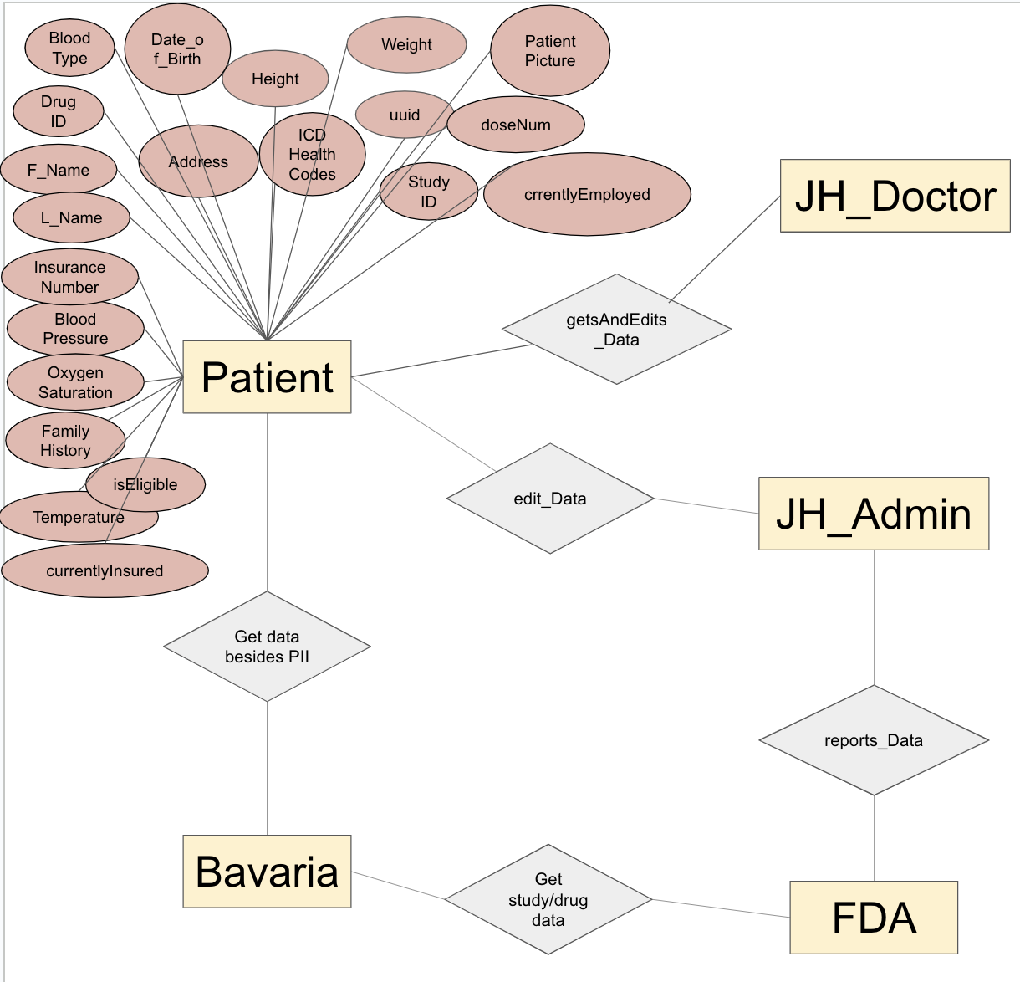

1. Architectural Design - a high-level overview of the system, its major components, and how these components are connected.
   1. Website
      1. 3 Views:
         1. Jane Hopkins
            1. Patient Table
         2. FDA
            1. Study Table
         3. Bavaria
            1. Patient Table
            2. Study Table
      2. Each view interacts with others through Vendia
      3. Buttons to change values in Vendia
2. Detailed Design
   1. Jane Hopkins Sequence Diagram

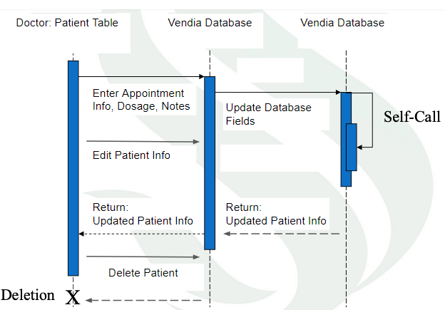

* 1. FDA & Bavaria Sequence Diagram

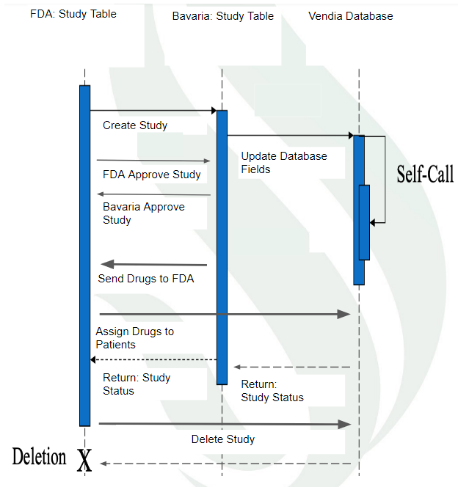

1. User Interface Design
   1. The Interface Design describes internal and external program interfaces. Interface designs are based on the information obtained from the analysis models.
   2. User Stories:
      1. As a Jane Hopkins doctor, I want to be able to see all my patients so that I can access my patient's information.
      2. As a Jane Hopkins doctor, I want to be able to add a new patient so that I can take on new patients.
      3. As a Jane Hopkins doctor, I want to be able to edit an existing patient so that I can stay up to date with my patients.
      4. As a Jane Hopkins doctor, I want to be able to create an appointment so that I can schedule appointments for my patients.
      5. As an FDA user, I want to be able to create a case study so that I can start a new drug trial.
      6. As an FDA and Bavaria user, I want to be able to see which case studies are approved, pending and completed so that I can properly track them.
      7. As a Jane Hopkins admin, I want to be able to administer doses so that I can advance a case study.
      8. As a Jane Hopkins admin, I want to be able to see which patients are eligible to receive drugs so that I can see how many patients can participate in a case study.
   3. User Interface Design Diagrams:

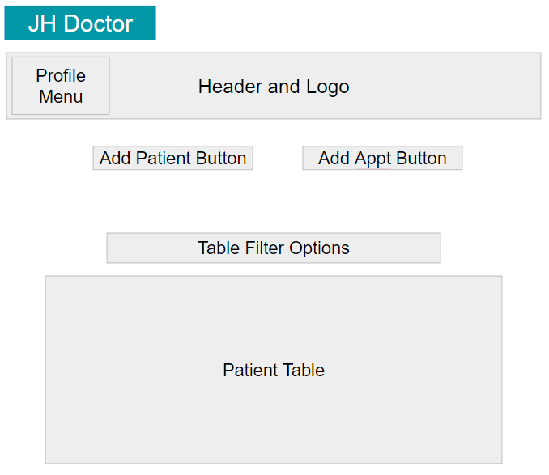

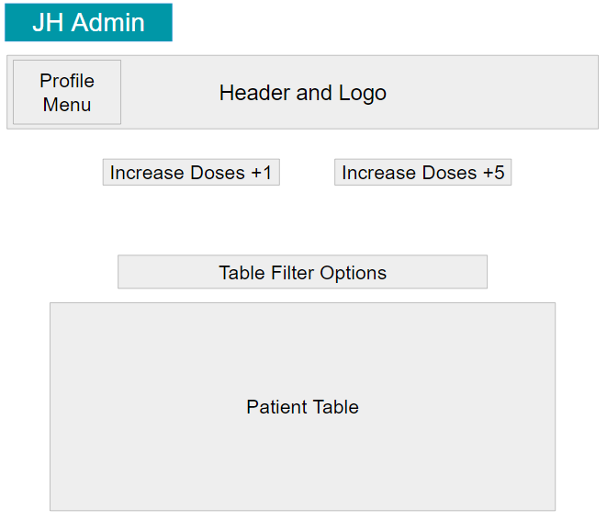

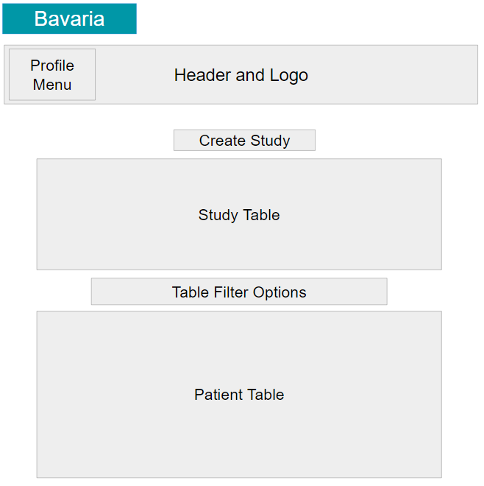

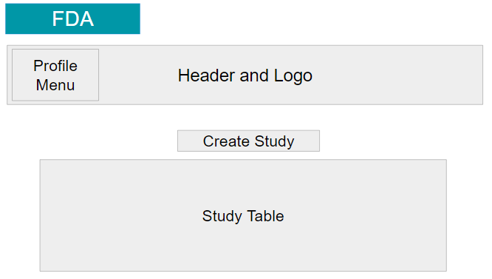

1. Technology and Tools
   1. Front end: React, Bootstrap
   2. Back end: Vendia
   3. Authentication: Firebase
   4. Version control: GitHub
2. Assumption and constraints
   1. All team members are new to React, Vendia, Bootstrap, and database systems, with no previous experience.
   2. Members learned the different tools and platforms for this project.
   3. There was a lot of trial and error and collaboration to piece together all the requirements for this project.